


National University of Computer & Emerging Sciences Peshawar Campus

Applied Physics. Assignment# 04
NOTE: The scan copy of assignment should be submitted before due date.
For each answer write the question before with given figure if, that was given in question.
Caution: Plagiarism will lead to ZERO marks being awarded in the assignment.
Last date of submission: 10-06-2020 (Read the instructions carefully).

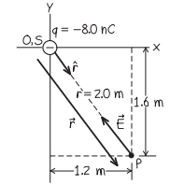
PROBLEM 1: A point charge is located at the origin. Find the electric field vector at the point x = 1.2 m and y = -1.6 m.

PROBLEM 2: A circular ring of charge with radius b has total charge q uniformly distributed around it. What is the magnitude of the electric field at the center of the ring?

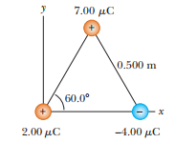
PROBLEM 3: Three charged particles are located at corners of an equilateral triangle as shown in figure. Calculate the total electric force on the 7.00 μC charge.

PROBLEM 4: Two small beads having positive charges 3q and q are fixed at the opposite ends of a horizontal insulating rod, extending from the origin to the point x = d. As shown in Figure P23.8, a third small charged bead is free to slide on the rod. At what position is the third bead in equilibrium? Explain whether it can be in stable equilibrium.
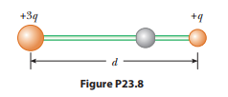

PROBLEM 5: A point charge$q=-8 nC$, is located at the origin. Find the electric-field vector at the field point x =1.2 m, y = -1.6 m.

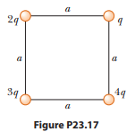
PROBLEM 6: Four charged particles are at the corners of a square of side a as shown in Figure P23.17. (a) Determine the magnitude and direction of the electric field at the location of charge q. (b) What is the total electric force exerted on q?

PROBLEM 7: A rod 14.0 cm long is uniformly charged and has a total charge of -22.0 μC. Determine the magnitude and direction of the electric field along the axis of the rod at a point 36.0 cm from its center

PROBLEM 8: A uniformly charged ring of radius 10.0 cm has a total charge of 75.0 μC. Find the electric field on the axis of the ring at (a) 1.00 cm, (b) 5.00 cm, (c) 30.0 cm, and (d) 100 cm from the center of the ring.

PROBLEM 9: A uniformly charged disk of radius 35.0 cm carries charge with a density of
σ = 7.90 × 10⁻³ C/m². Calculate the electric field on the axis of the disk at (a) 5.00 cm, (b) 10.0 cm, (c) 50.0 cm, and (d) 200 cm from the center of the disk.

PROBLEM 10: A spherical shell carries charge Q uniformly distributed over its surface. If the charge on the shell doubles, what happens to the electric field (a) inside and (b) outside the shell?

Problem 11: Two known charges, -12.0 μC and 45.0 μC, and a third unknown charge are located on the x axis. The charge -12.0 μC is at the origin, and the charge 45.0 μC is at x = 15.0 cm. The unknown charge is to be placed so that each charge is in equilibrium under the action of the electric forces exerted by the other two charges. Is this situation possible? Is it possible in more than one way? Explain. Find the required location, magnitude, and sign of the unknown charge.

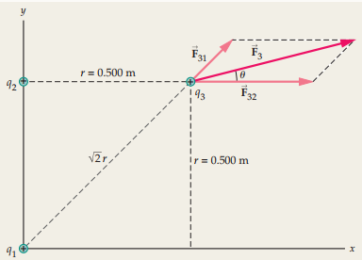
Problem 12: Three charges each equal to + 2.90 μC are placed at three corners of a square 0.500 m on a side, as shown in the diagram. Find the magnitude and direction of the net force on charge 3.

Problem 13: At what separation is the electrostatic force between a + 11.2-μC point charge and a + 29.1-μC point charge equal in magnitude to 1.57 N?

